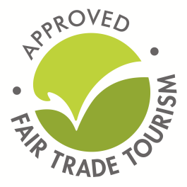
Amatungulu supports Fair Trade Tourism, a non-profit organisation promoting best-practice tourism in Africa which runs a membership program for tourism businesses that are keen to embark on the path towards best sustainable practices and the specific principles of Fair Trade to promote responsible business practice.
Certified Fair trade Members: Fair trade certified members have gone through extensive sustainability training and have been independently audited against rigorous criteria. The criteria focus on environmental practice, community resources, cultural heritage, business practices and HR. The use of our Fair Trade Label endorses best practice tourism organisations.
Following is a list of Fair Trade Tourism certified places to go.
Cape Town/Stellenbosch Accommodation:
http://www.antrimvilla.com/
https://www.backpackers.co.za/
https://www.townhouse.co.za/
https://once.travel/cities/cape-town/
https://www.vineyard.co.za/
http://www.spier.co.za/
https://www.oudewerf.co.za/
Gauteng accommodation:
http://leriba.co.za/
https://www.accorhotels.com/gb/africa/index.shtml
http://thepeech.co.za/
http://www.thabahotel.co.za/

